Prospect High School All Program Football BBQ
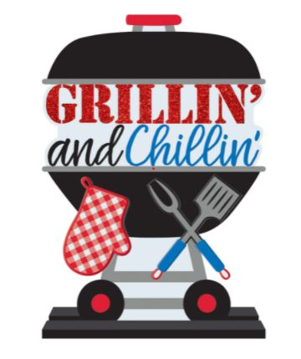
For All Prospect Football Players, Families, and Coaches:

The Program BBQ, Practice and Parent Meeting will be Saturday,
August 21, 2021.

Saturday’s Schedule:
9:00 am – 10:30 am Invitation to Watch the Players Practice

10:30 am – 10:45 am Football Program Meeting for All Parents (Cafeteria – enter through Door 29)

11:00 am – 12:30 pm Program BBQ (Cafeteria – enter through Door 29)

The BBQ will be held immediately following the parent meeting in the Cafeteria. (Please enter through Door 29)

Hot Dogs, Brats, and Water will be provided by the PPFC. Please bring the following dish according to your last name:

- A - E Salads (May include pasta salad, taco salad, macaroni salad, or potato salad)
- F - O Cut Fruit or Vegetables
- Q – Z Desserts

No refrigeration is available – please keep all perishables in coolers and/or feel free to drop it off in the Field House prior to the scrimmage. PLEASE LABEL YOUR BOWLS, SERVING TOOLS. ETC.

OPTIONAL: We are also asking that JV and Varsity families ONLY donate 1 case of water or 1 case of Gatorade to be used throughout the season for Thursday night and Friday night meals. These may be dropped off in the cafeteria upon your arrival.

You will also have the opportunity to purchase a Prospect Football yard sign. These are $30 each. Please plan to pay by cash, check (made out to PPFC) or Pay Pal. You will be able to take the sign with you on the day of the BBQ. New or additional player jersey numbers for your sign will be available at this time, as well.

GO KNIGHTS!
Michele Grassano and Maria Grzesiak
If you have any questions please feel free to email us at michelegrassano@yahoo.com or maria.subia@att.net.

